LAB 1
HU22CSEN0102013
B.TEJ PRAVARDHAN
WHAT IS GIT?
GIT is the version control system that lets developers track changes in the codebase over time. It is free and an open-source tool created by Linus Torvalds in 2005.
GIT enables multiple developers to collaborate on a project by allowing:
1. Tracking changes made in the code
2. Creating a history of all the changes
3. Enabling multiple versions of the code to coexist
4. Facilitating collaboration and merging of changes

GIT is highly used in software development but can be used for anything else like tracking changes in documents or websites.

WHAT ARE THE DIFFERENCES BETWEEN GIT AND GIT HUB
GIT | GIT HUB
Git is a software. | GitHub is a service.
Git is a command-line tool. | GitHub is a graphical user interface.
Git is installed locally on the system. | GitHub is hosted on the web.
Git is maintained by linux. | GitHub is maintained by Microsoft.
Git is focused on version control and code sharing. | GitHub is focused on centralized source code hosting.
Git is a version control system to manage source code history. | GitHub is a hosting service for Git repositories.
Git was first released in 2005. | GitHub was launched in 2008.
Git has no user management feature. | GitHub has a built-in user management feature.
Git is open-source licensed. | GitHub includes a free-tier and pay-for-use tier.
Git has minimal external tool configuration. | GitHub has an active marketplace for tool integration.
Git provides a Desktop interface named Git Gui. | GitHub provides a Desktop interface named GitHub Desktop.
Git competes with CVS, Subversion, Mercurial, etc. | GitHub competes with GitLab, Bit Bucket, AWS Code Commit, Azure DevOps Server, etc.

HOW TO CREATE PROFILE IN GIT

Setting up Git

1. Install Git: Download and install Git from the official website (https://git-scm.com/downloads) if you haven't already.
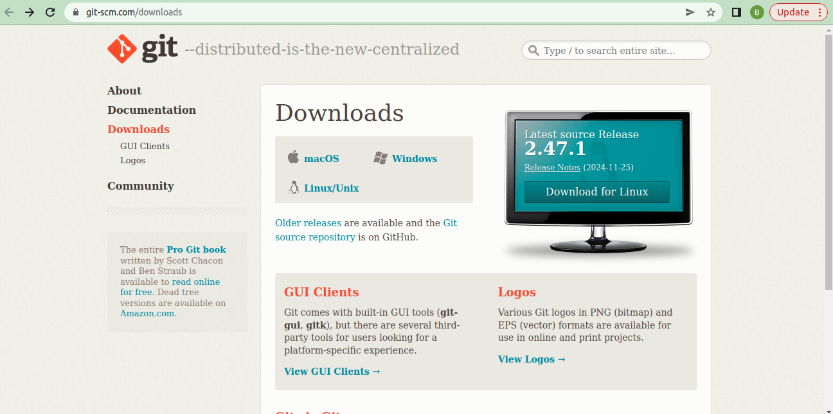
2. Open Terminal/Command Prompt: Open a terminal or command prompt on your computer.

Configuring Your Git Profile

1. Set Your Name: Type the following command to set your name:

git config --global user.name "Your Name"

Replace "Your Name" with your actual name.

2. Set Your Email: Type the following command to set your email:

git config --global user.email "your_email@example.com"

Replace "your_email@example.com" with your actual email address.

3. Verify Your Configuration: Type the following command to verify your configuration:

git config --list

This will display your Git configuration, including your name and email.

Creating a GitHub Profile (Optional)

If you want to create a GitHub profile, follow these steps:

1. Go to GitHub: Go to the GitHub website (https://github.com/).
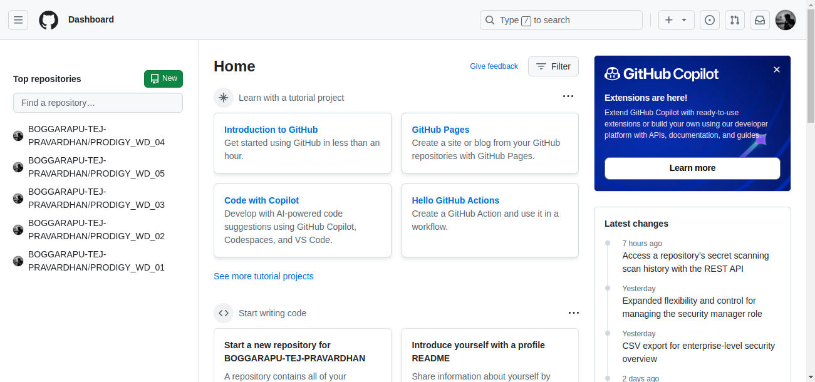
2. Sign Up: Click on the "Sign up" button and fill out the registration form.
3. Verify Your Email: Verify your email address by clicking on the link sent by GitHub.
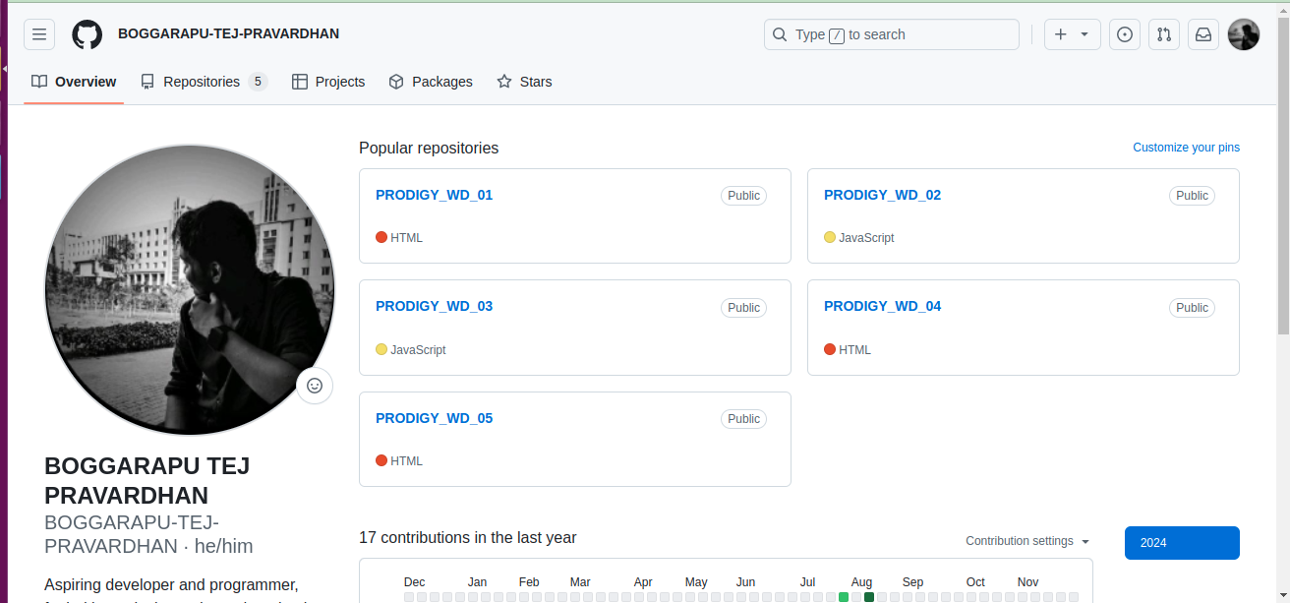
4. Complete Your Profile: Complete your profile by adding a profile picture, bio, and other details.
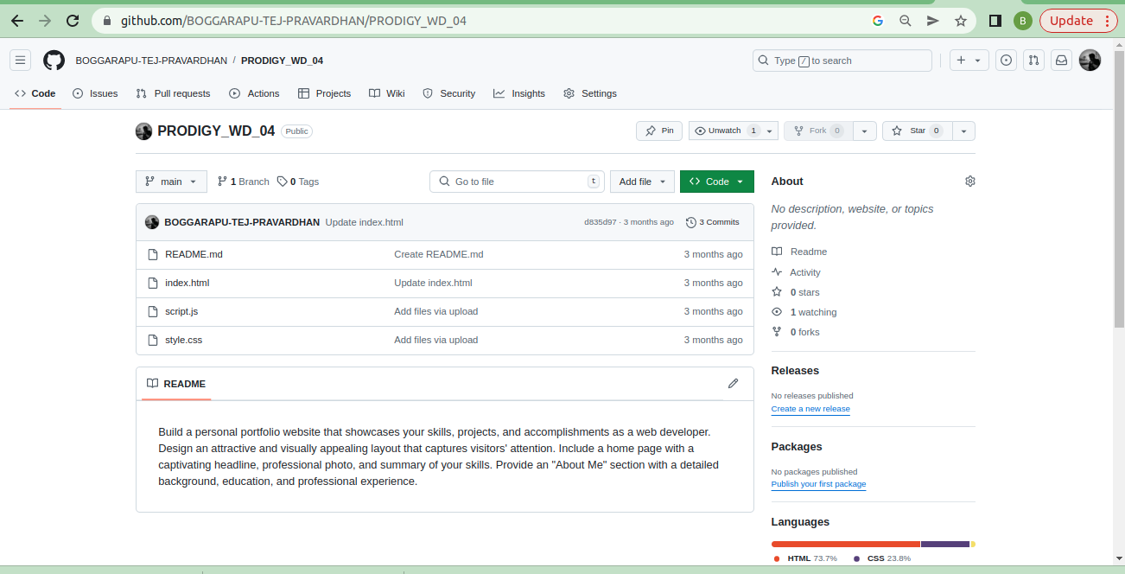
5.now make repositories to store your work

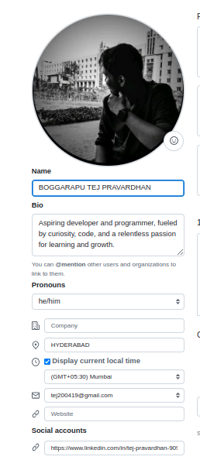

That's it! You now have a Git profile set up, and optionally, a GitHub profile.

